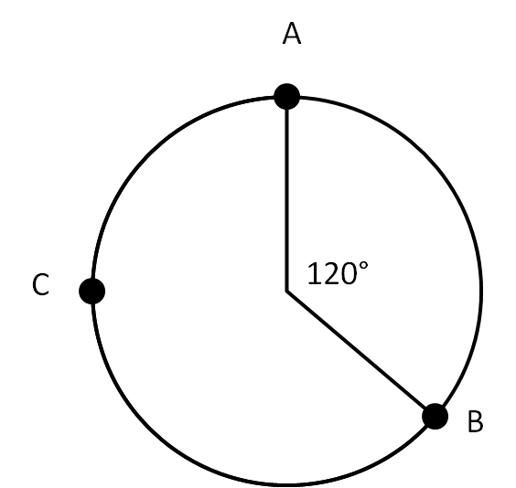
Use the diagram for problems 1-3.
- Find measure of arc AB.

- What is the circumference if the radius is 5.

- Find the length of arc ACB.

- Write the equation of a circle with radius 5 centered at the point (-2,-3).

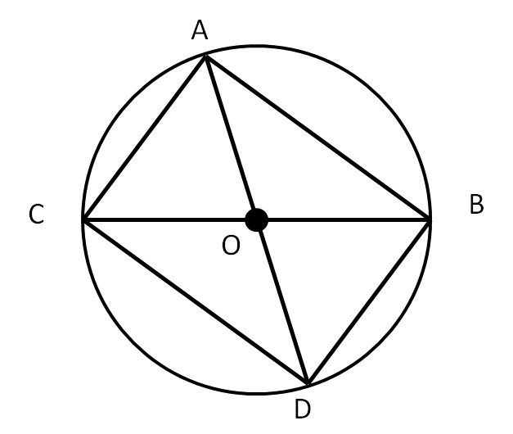

- If ABCD has height 8 and width 15, what is the radius of the
circle.

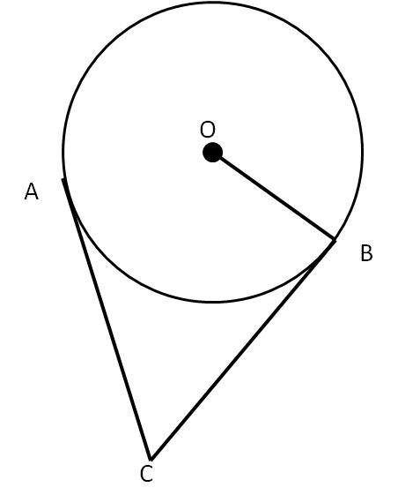
Use the diagram to answer 6-7.
- If $\overline{CA}=2x-1$ and $\overline{CB}=4x-5$, find the radius of the circle
if $\overline{OB}=3x-1$.

- If $m\hat{AB}=60°$, find the measure of angle C (or angle ACB).

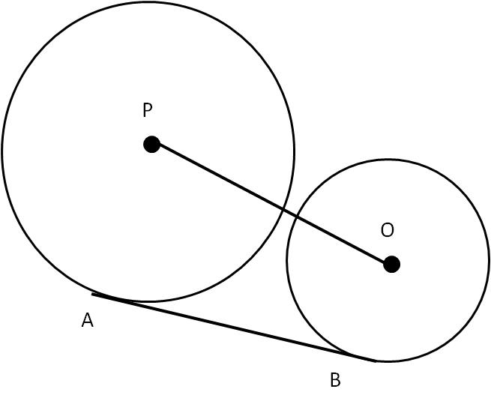
- If AB = 24, the radius of O = 5 and the radius of P = 15
find PO.

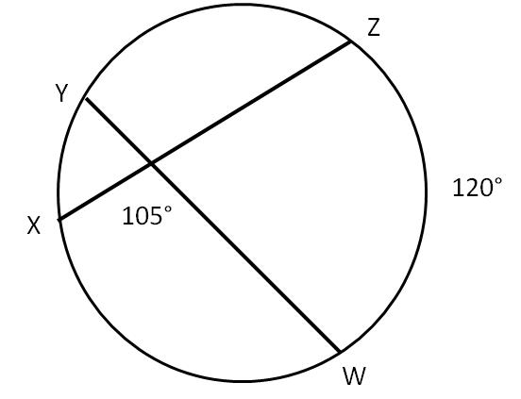
- Find $m\hat{YX.}$

- Find, to the nearest centimeter, the circumference of a circle in which a 24 cm chord
is 5 cm from the center.

- The centers of two circles with radii 3 and 5 are 10 units apart. Find the length of a common internal tangent.

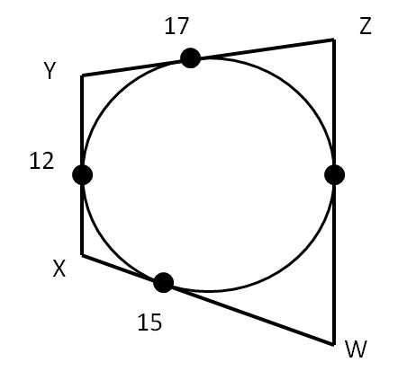

- Find the length of segment ZW based on the image shown:

Z
W
Y
X
80

- Find the measure of angle X if the ratio
of arc YW to arc WZ is 3:4.

- M is the midpoint of arc AB. Find the measure

x+7
3x-31
4x-14
A
M
B
C
D
of arc CD (all measures are in degrees).

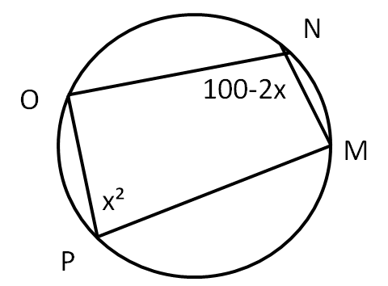
- Find the measure of angle P (all measures are in degrees).

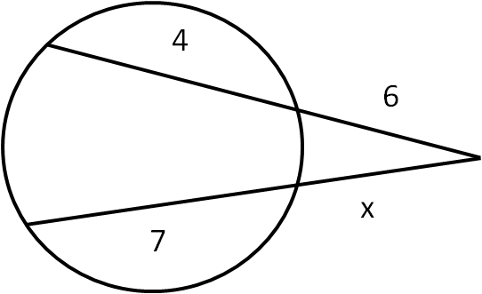
- Solve for x.

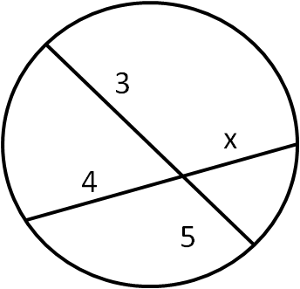
- Solve for x.

