**Intervention: Addition, Subtraction, Multiplication, and Division Properties**

Name_______________________________

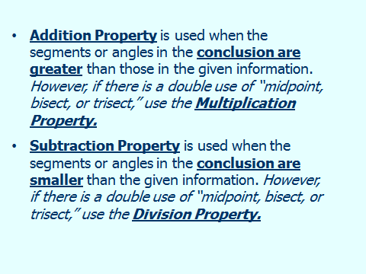

1)



|  |  |
| --- | --- |
| **Statements** | **Reasons** |
| 1) | 1) |
| 2) | 2) |

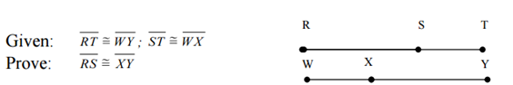

2)

|  |  |
| --- | --- |
| **Statements** | **Reasons** |
|  |  |

**C**

**B**

3)

Given: 

M is the midpoint of 

**M**

M is the midpoint of 

**D**

**A**

Prove: 

|  |  |
| --- | --- |
| Statements | Reasons |
|  |  |