Division of Segments & Angles Name__________________________
Intervention Block______

- Complete the following statements.
M
H
A
T
R

a) MR = 24, HR = ______ b) TR = 16, AT = ______

c) MH = 58, MR = ______

d) R is the midpoint of ______ and ______.

2. Given AB to the right,
A

_____a) how many midpoints does it have?
B

Use Figure 2 for problems 4-8.
W
A
S
Q
B
-8
0
2
4
8
3. What is the midpoint of AQ?

4. What is the coordinate of the midpoint of WS?
Figure 2
5. What is the coordinate of the midpoint of SB?

6. The coordinate of the midpoint of AR is -3.
What is the coordinate of point R?

7. The coordinate of the midpoint of ST is 5.
What is the coordinate of point T?

Use Figure 3 for problems 9-10.
T
B
A
M
Q
9. If TM = 2x + 5, MQ = x + 14, find the value of x.

10. If AM = 4y – 2, AB = 20, find the value of y.
Figure 3

11. E bisects DF, DE = 2y, and EF = 8y-3. Find DE, EF, and DF.

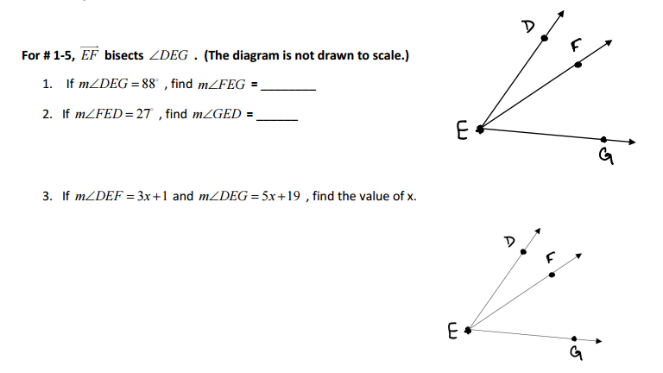
Assume for #1-4 the $\vec{EF}$ bisects $<DEG.$

