3. 4.
Find the area.
Find the area.
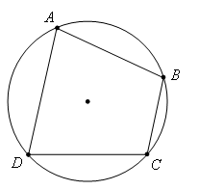
24
20
15
7
21
10
9
10

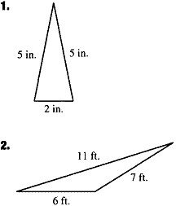
Find the area.
Find the area.

5.
Find ratio the areas of the similar triangles.
7
3

Find ratio the areas of the similar figures.
6.

2
5

7. Find the ratio of Area I to Area II. 8. Find the ratio of Area A to the whole triangle.
A
II
I

9. If the ratio of the areas of two similar triangles is 25:81, find the ratio of their corresponding altitudes.

10. The ratio of the areas of two similar decagons is 18:50. Find the ratio of their perimeters.

Advanced Geometry Stations Name__________________________
Ratio of Areas, Hero, and Brahmagupta Date ______________ Block _______

1. | 2.
3. | 4.
5. | 6.
7. | 8.
9. | 10.

