Intervention: Perpendicularity Name____________________

- If 2 segments are _____________________________, then they form a right angle.

- If 2 segments form a right angle, then they are _____________________________.

- ABCD is a rectangle.
- Find the coordinates for B and D.
- Find the area.
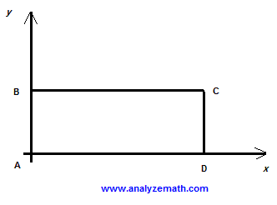
(10, 4)

4)
