Name_________________________

Date _____________ Block _______

**Advanced Geometry**

**Proving Triangles Congruent**

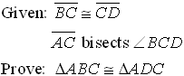 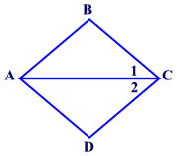

|  |  |
| --- | --- |
| **Statements** | **Reasons** |
| 1) | 1) |
| 2) | 2) |
| 3) | 3) |
| 4) | 4) |
| 5) | 5) |

1. 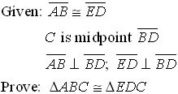 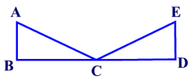

|  |  |
| --- | --- |
| **Statements** | **Reasons** |
| 1) | 1) |
| 2) | 2) |
| 3) | 3) |
| 4) | 4) |
| 5) | 5) |
| 6) | 6) |
| 7) | 7) |

1. 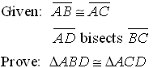 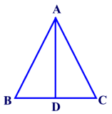

|  |  |
| --- | --- |
| **Statements** | **Reasons** |
| 1) | 1) |
| 2) | 2) |
| 3) | 3) |
| 4) | 4) |
| 5) | 5) |

1. 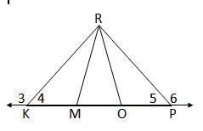

**Given:** 

**Prove:** 

Given: ∠3 ≅ ∠6

KR ≅ PR

∠KRM ≅ ∠PRM

Prove: ΔKRM ≅ ΔPRO

Given: ∠3 ≅ ∠6

KR ≅ PR

∠KRM ≅ ∠PRM

Prove: ΔKRM ≅ ΔPRO

Given: ∠3 ≅ ∠6

KR ≅ PR

∠KRM ≅ ∠PRM

Prove: ΔKRM ≅ ΔPRO

|  |  |
| --- | --- |
| **Statements** | **Reasons** |
| 1) | 1) |
| 2) | 2) |
| 3) | 3) |
| 4) | 4) |
| 5) | 5) |
| 6) | 6) |
| 7) | 7) |

5)

T

S

Q

R

Statements Reasons

Given: 



Prove: 

6) Statements Reasons

5

4

6

2

3

1

M

J

K

L

N

Given: L is the midpoint of 



Prove: 

7) Statements Reasons

A

R

O

M

G

N

Given: 



Prove: 

A

8)

•

Y

M

D

N

Statements Reasons

Given: 



Prove: 