Advanced Geometry Name_____________________________________
Rotating 2D Figures Date ___________________ Block_____________

Rotate the figure around the axis (draw it) and find the volume.

- 2.
6 cm
12 cm
8 mm
8 cm

- 4.

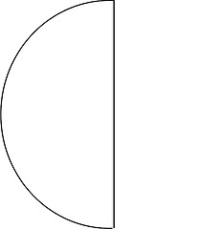
3 in.
18 in.
4 in.
10 in.

